1.





2.

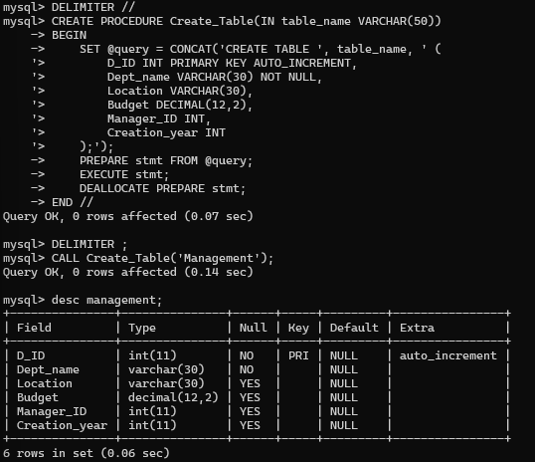

4.

5.

6.

7.

